**Data Analysis & Report**

**Prepared for Surefoot**

**Shyni David**

**October 2019**

**Brief Purpose/Description of the Marketing Test**

The test was to determine the impacts on 1) Average Order Value (AOV) and 2) Revenue, by comparing shopping behavior of visitors with and without an incentive. The incentive was a free gift for purchases of at least $100, promoted through a new feature added to the client’s store website.

**Deliverable a.1.1)** Average Order Value (AOV)

**Conclusion 1:** There was a positive impact on AOV when the visitors chose the free gift incentive (Fig. 3).

**Deliverable a.1.2)** Total Revenue

**Conclusion 2:** There was a positive impact on Total Revenue per transaction when the visitors chose the free gift incentive (Fig. 8).

**Deliverable a.2)** Incentive-driven spending effect

**Conclusion 3:** The free-gift incentive encouraged visitors to add more items to cart to reach $100 threshold (Fig. 10). However, the visitors choosing the free-gift incentive would have spent $100 regardless (Fig. 9).

**Deliverable a.3)** Alternative metrics explored

**Conclusion 4:** There are a few other metrics that I would like to specifically consider:

1. Impact of Cost incurred –The incentive added a cost factor of $7 per transaction to the client. In the test scenario, when visitors chose the incentive, total cost incurred to the client was $1932. When visitors were shown GWP and preferred not to choose the incentive, it saved the client a cost of $16,604 (Fig. 12).
2. Quantity of items -The total quantity of items purchased per transaction that amounts to at least $100 when they chose the free incentive was, 57% more than when visitors were not shown the incentive and when the purchased items were at least $100 (Fig. 11).

**Deliverable a.4)** Where will the client go from here?

**Recommendations:**

Based on all of the conclusions detailed above, the client may consider offering gift with purchase (GWP) as a regular or seasonal website feature going forward.

* The visitors receiving hats would have spent $100 regardless of the incentive offer (Fig. 9). However, because of the incentive, the AOV increased (Fig. 3) and there was a strong lift in Revenue (Fig. 8). Revenue growth can positively impact the client when AOV increases. Since it is well known that for data-driven businesses, AOV metric helps to set goals and strategies and also to evaluate how well these strategies are working, it is imperative for the client to consider adding “gift with purchase” feature to the website.
* The analysis also brought out the fact that a greater number of items were purchased with the incentive (Fig.10). Since we also observe an increase in AOV as mentioned earlier, some of the successful strategies for increasing AOV that can be recommended to the client are cross-selling, upselling, volume discounts, free shipping, coupons and return policy.
* Another interesting feature that worked towards the client’s benefit was that the cost incurred to client, because of the incentive, was very low (Fig. 12). The client can take advantage of understanding visitor behavior and make this incentive as a seasonal offer rather than a year-round offer after due diligence, which is likely to make the offer more attractive to visitors. As there is a transaction cost of $7.00 associated with Gift with purchase for the client, increasing AOV is a way to drive direct revenue, increase profits and reduce cost, as the visitor is buying regardless.

**Deliverable b)**

Fig. 1 was derived from the two sample t-test done when the Total Revenue per transaction was at least $100 between AOV when the Gift with Purchase was not shown to the visitors and when the Gift with Purchase was shown and chosen.

The t-test is an inferential statistics for Potential outcome and shows that there is significant statistical difference in the group means between control and treatment groups. The null hypothesis that there is no difference in mean before and after the test qualifies to be rejected. It indicates that data readings are strong and not by chance.

Figure 1

Note: Here Qualify_GWP means the visitors are shown GWP and the Total Revenue is at least $100.

A freqpoly graph (Fig. 2) shows high AOV also shows the significance of Gift with Purchase Option.

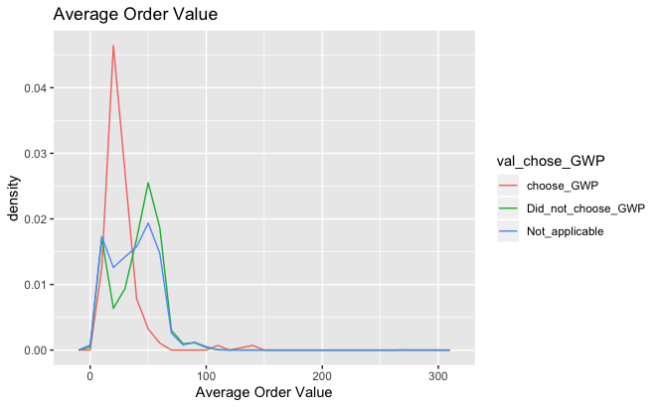

Figure 2

Based on calculations as below in Fig. 3, Fig. 4, Fig. 5 and Fig. 6 AOV for Gift with Purchase is the highest.

1. In Fig. 3 calculates AOV when the incentive is shown and the Total Revenue per transaction is at least $100 and the visitor do chose GWP(selecting records when cost is incurred by the client).

Figure 3

1. Fig. 4 shows the calculation of AOV when the incentive is shown and the Total Revenue per transaction is at least $100 and the visitor did not choose GWP (selecting records when no cost is incurred by the company as qualified visitors did not choose GWP).

Figure 4

1. Fig. 5 shows the calculation of AOV when the incentive is shown and the Total Revenue per transaction is at least $100.

Figure 5

1. Fig. 6 shows the calculation of AOV when the incentive is not shown and the Total Revenue per transaction is at least $100.

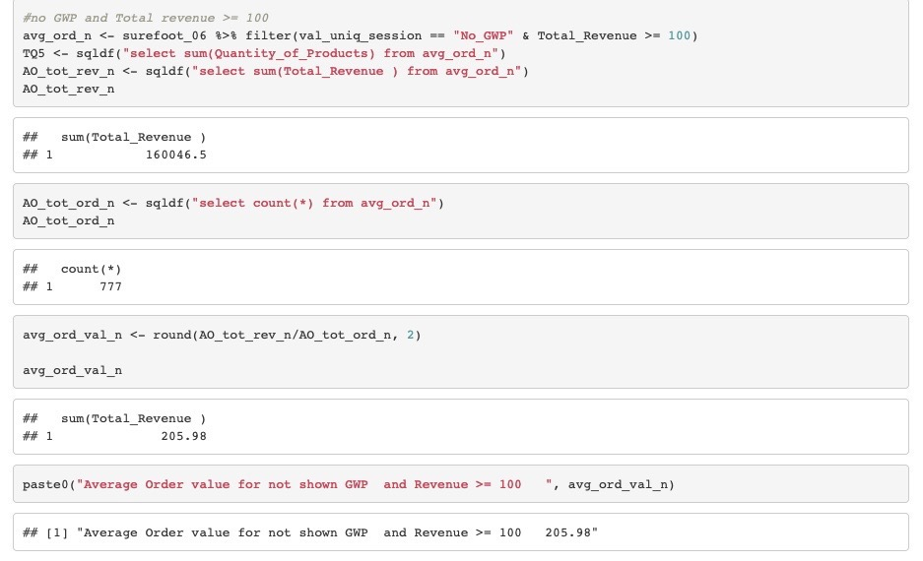

Figure 6

Fig. 7 is derived from the two-sample t-test done when Total Revenue per transaction was at least $100 between Total Revenue when the Gift with Purchase was not shown to the visitors and when the Gift with Purchase was shown and chosen.

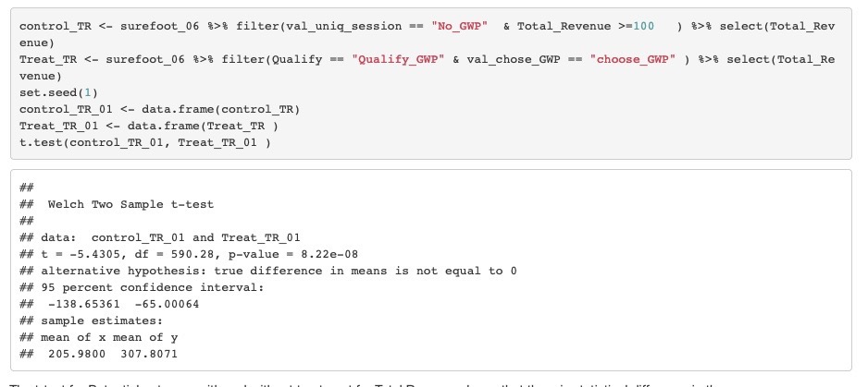

Figure 7

Note: Here Qualify_GWP means the visitors are shown GWP and the Total Revenue is at least $100.

The differences-in-differences(DD) method (Fig. 8) is used to determine the causal effect on the Total Revenue after the treatment of allowing visitors to use the incentive.

The Post period is when the visitors are shown GWP. We are comparing the Transactions with Total Revenue at least as $100 before and after the Gift with Purchase, and see if there is any variation because of the treatment when the visitor choses GWP.

The interaction term (Treat1:Period_post) is the DD causal effect of interest.

For every one unit addition of choosing GWP, the Total Revenue value has a lift of approx. $75.96.

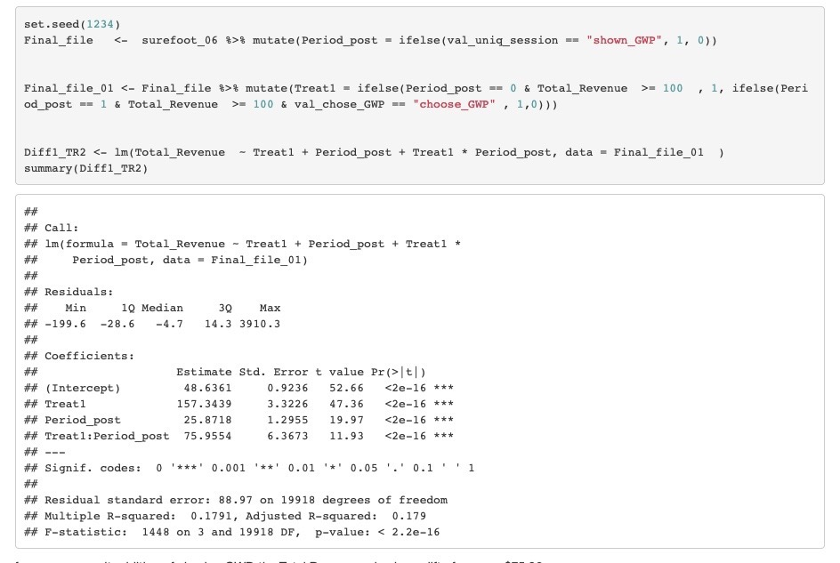

Figure 8

In Fig. 9 for those who did not chose GWP the Quantity of products were a few like 1 , 2, 4, 6 and 8 and the number of visitors were significantly high.

Figure 9

When compared with Fig 10 for those who chose GWP, the range of total quantity purchased was larger, however, the number of visitors were spread out and significantly lower.

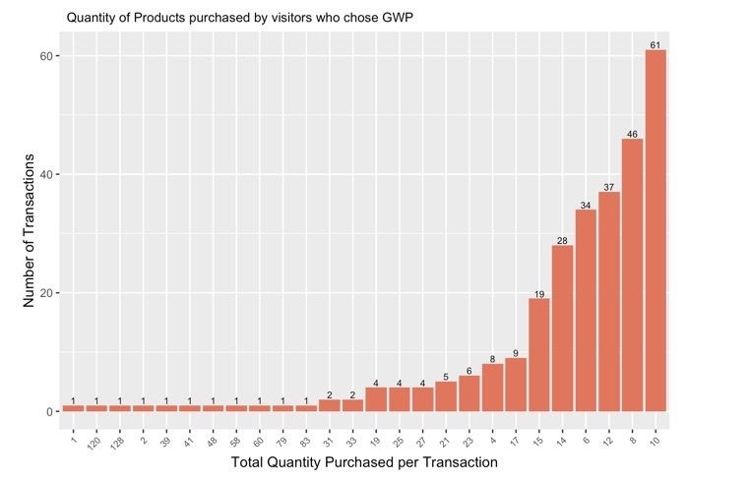

Figure 10

The Total Quantity of Products purchased per transaction was 12,596 and is the highest (Fig. 11) when the visitors were shown GWP and the Total Revenue was at least $100.

Figure 11

In Fig.12, for the current test scenario, there is a good combination of lower cost incurred to the client and higher AOV when visitor chooses gift with purchase.

Cost of $7.00 is incurred by the client, when the visitor is shown GWP and the Total Revenue per transaction is at least $100 and the visitor chooses Gift.

Cost of $7.00 is not incurred by the client, when the visitor is shown GWP and the Total Revenue per transaction is at least $100 and the visitor does not chooses Gift.

Figure 12

**Deliverable c) Anomaly in Dataset**

* Out of the 19,922 observations in Surefoot database, there were only 6 records with incomplete information on Total Revenue that had $0 value (Fig. 13). It was relatively insignificant and did not affect the overall analysis.

Figure 13

* As an anomaly, Fig. 14 shows that there are 4 transaction observations where visitors were shown GWP but had a Total Revenue less than $100(Do_not_Qualify_GWP) and they were able to choose the gift with purchase.

Figure 14

**Deliverable c) Recommendation on new variables**

* One variable that would help in meaningful analysis is the duration of the incentive or the Date of the transaction. This will help in understanding visitor behavior of those who tend to choose incentive, which in turn can be used in planning the seasonal promotions of GWP and thus also efficiently manage the cost associated with the free gift for the client, and simultaneously increase AOV.
* Another variable that can possibly be added is “Visitor names”. This can help in determining the

1. Return Per Visitor (RPV): It is a measurement of the amount of money generated each time a visitor uses the Client’s website. It is calculated by dividing the total revenue by the total number of visitors to the site, and is a method of estimating the value of each additional visitor.
2. Conversion Rate: It is defined as the total number of visitors divided by the number of conversions made on the Client’s website. The higher the conversion rate, the higher the multiplier of the AOV will be for overall revenue.

~~~~~~~~~~~~~~~~~~~~~~~~~~~~